Solution To T24 Chromatography Printing

V1.0

Version | Date | Description | Author
1.0 | 2011-07-10 | Create document | Matt Zheng
1.1 | 2011-07-14 | It’s more clear | Matt Zheng

Modify D.SLIP
Execute DE.FORM.TYPE, I D.SLIP
Set “Top Margin” and “Bottom Margin” to “0”，Set “Options.1” to “NOHEAD”
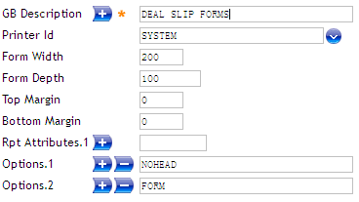

Check configuration of REPORT.CONTROL
Execute REPORT.CONTROL, I CU.DEAL.SLIP
Make sure “Form Name” value is “D.SLIP” mentioned in the 1st step.
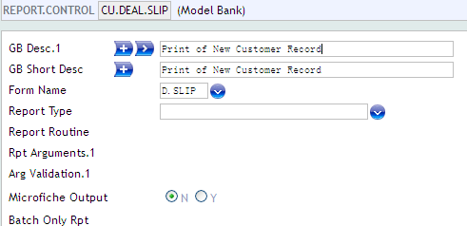

CREATE DEAL.SLIP.FORMAT
Take CUSTOMER for example，create a DEAL.SLIP.FORMAT named “PRINTTEST”
FILE field is the name of the Application –“CUSTOMER”
“Report Control Id” with value ”CU.DEAL.SLIP”
Add several Fields, with name of CUSTOMER’s fields, such as “MNEMONIC”, “SHORT.NAME” etc,.
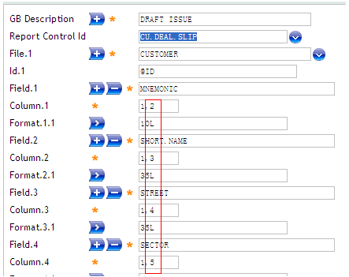
NOTICE: Format of Column values is “X,Y” ，which means abscissa and ordinate. Convenient for printing page to get values, Y MUST be consecutive numbers from 2(if from 1, a copy of the last character in the 1st line will be in the 2nd line, it might be ModelBank’s bug). In this solution, X is not very useful, but don’t set it too large, to avoid spaces.

Create printing template ”test.xsl ”
Xsl file is xml formed, with architecture like this
<?xml version="1.0"?>
<xsl:stylesheet version="1.0" xmlns:xsl="http://www.w3.org/1999/XSL/Transform">
<xsl:template match="/">
//We can insert standard html here
</xsl:template>
</xsl:stylesheet>

Here’s the chromatography printing layout of cheque, position elements with CSS+DIV way, source code please refer to “test.xsl”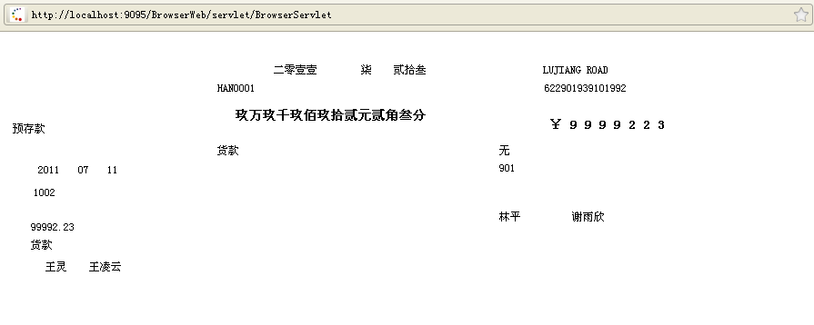
NOTICE: In this xls file, we add a hidden field
<input type="hidden" id="respContent">
<xsl:attribute name="value"><xsl:value-of select="/responseDetails/window/panes/pane/dataSection/enqResponse/r/c/rpt"/></xsl:attribute>
</input>
with the purpose to get value from “PRINTTEST” created in the 1st step. while generating the page, values from VERSION “CUSTOMER,CUSTPRINT1” (this VERSION will be created in next step)will be rendered in the page, like the following image.
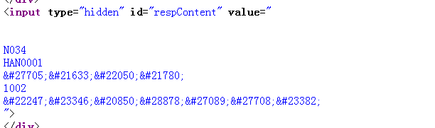
The value of the hidden field, can be split by javascript split(“\n”),then get value from the splited array begin with index 3,and then fill into specific div, finally print the page, T24 value to cheque chromatography printing is done.

About <xsl:value-of select=” /responseDetails/window/panes/pane/dataSection/enqResponse/r/c/rpt"/>
RAW DATA T24 DEAL.SLIP.FORMAT generated is xml formed, as the following image
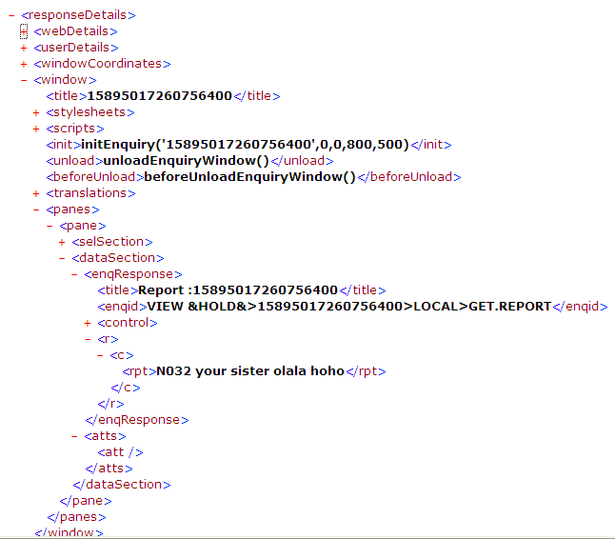
It can be seen that select’s value is the XPath for data node “rpt”

Create A Customized CUSTOMER VERSION “CUSTOMER,CUSTPRINT1” Using ”PRINTTEST”
Specify it’s D Slip Format
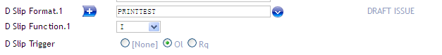
and Style sheet
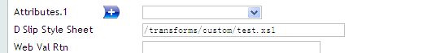
here’s the created VERSION
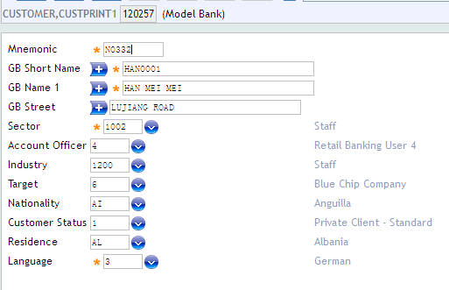

Configure Local Printing in T24
Click “Tools”
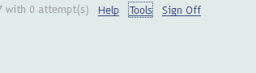
choose ”Amend Preferences” in “My Profile”, in the opening window, set “Print Location” to “Local”, save and relogin T24.
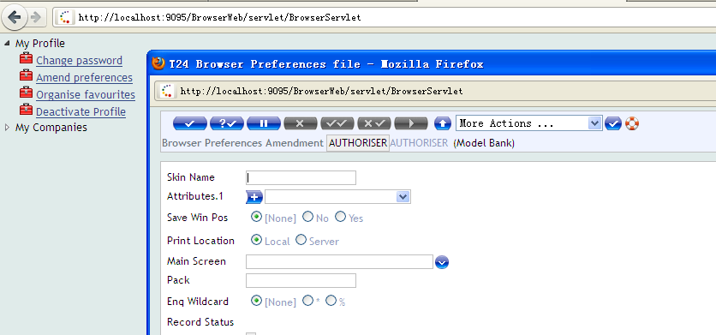

Printint page will be poped up after submitting transaction “CUSTOMER,CUSTPRINT1”.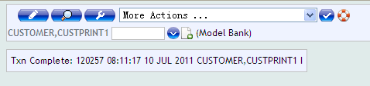
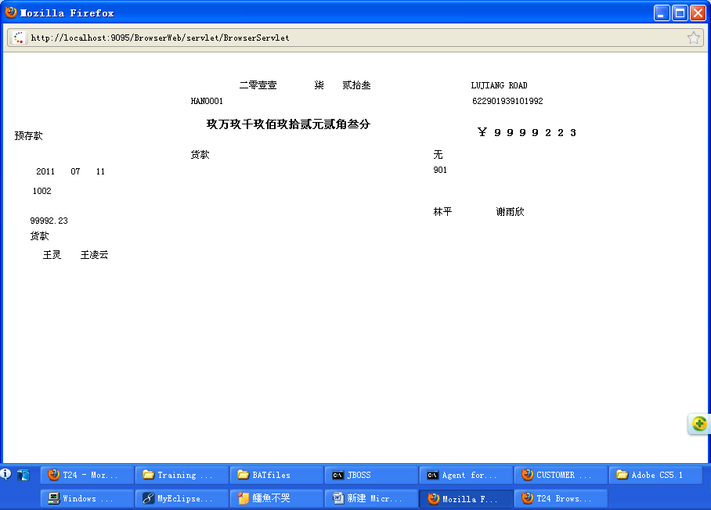
print this pupup page with right-click menu or “ctrl+p”
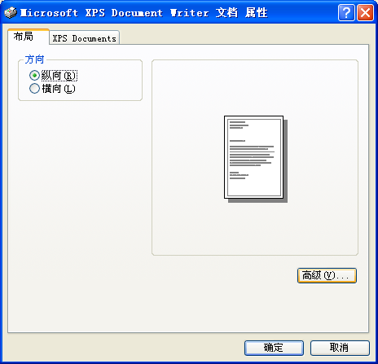
click “advance”, change paper type to “Letter” or else part of the printing content may in a new line.
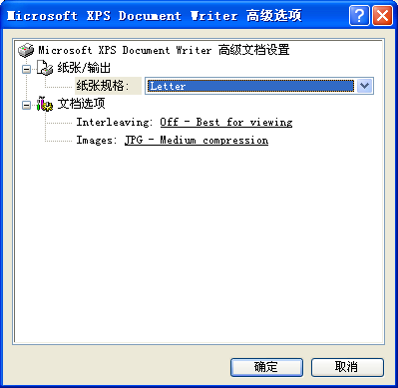
put in the queue and do the printing.

